

Policy Library Pro Forma

This information will be used to add a policy, strategy, guidance or procedure to the Council’s Policy Library.

Title: Providing Planned Short Break Services for Cared for People and their Carers - guidance for staff

Aim / Summary: This guidance sets out how staff should implement the Providing Planned Short Break Services for Cared for People and their Carers.

Document Type:

Policy | ☐ | Guidance | ☒
Strategy | ☐ | Procedure | ☐

Approved By: | Version Number *: 6.3
Date Approved:  21/01/2019 | Proposed Review Date:  January 2020

Author: Dan Godley | Responsible Team: Integrated Strategic Commissioning
Contact Number: 0115 9774596 | Contact Email: Dan.godley@nottscc.gov.uk

Publicly Available: | No
Adult’s Dept. only
Site Link: | Choose an item.

Area on Trix: Carers | Subheading: Carers (Staff Support Area)

Please Include Any Supporting Documentation:
Providing Planned Short Break Services for Adult Service Users and their Carers
- Policy
- NHS Short Breaks staff guidance – appendix 1

* If you are making changes to an existing document, please overwrite the previous version.

Review date | Amendments
12.04.2016 | Inclusion of Adults who are cared for Level of Need – definitions and removal of ‘charging’ reference when cancelling.
09.10.2017 | Inclusion of notes to alert that current document is under revision and is being updated.  NHS Short Breaks staff guidance document added in Appendix 1
19.08.2023 | Document title updated to reflect SBA and throughout the document. Data Input Team replaced with Service Placement Team. DP pre-payment card link updated

Providing planned short break services for People who are cared for and their carers – staff guidance

Contents
- Purpose of this guidance 3
  - Planned short break services 3
  - Shared Lives short break 4
  - Learning disability short breaks units 4
- Assessment of carers’ needs and eligibility for a service 4
  - Annual funding renewal 5
- The NHS Short Breaks Scheme 5
  - Carer’s Personal Health Budget through a Direct Payment (for NHS Carers Breaks) ... 6
- Creating an indicative personal budget for planned short breaks 6
  - Carer’s record 6
  - Adults who are cared for record 7
- Planned Short Breaks Matrix 8
- Deciding the appropriate level of personal budget for planned short breaks 9
  - Exceptional circumstances 10
- Booking the planned short break 10
  - Managed service 10
- Using a direct payment for a planned short break 11
- What to do if the combined cost of the service user’s personal budget and the personal budget for planned short breaks is very high 11
- Charging for planned short break services 11
- Transition period 11
- Process map 1 – requesting short break allocation set up 12
- Process map 2 – checking level of available short break allocation 12
- Process map 3 – request short break commissioning 13

*PLEASE READ FIRST*:

This version of the ‘Planned Short Break Services for Adults who are cared for and their Carers - guidance for staff’ document is now under revision. This is due to changes as a result of the implementation of Mosaic, and also changes to the NHS Short Breaks funding for ‘high impact’ level which has reduced from £950 to £650 with effect from 1st October 2017.

Please refer to appendix 1 for more information regarding the NHS Short Breaks for Carers.

A new version of this document is being drafted to accurately reflect changes and updates which apply to Short Breaks.

Any queries should be directed to Dan Godley, Senior Commissioning Officer 0115 977 4596 dan.godley@nottscc.gov.uk

Mosaic process queries should be directed to the Mosaic Development Team on 0115 977 3784 or via e-mail: frameworkdevelopmentteam@nottscc.gov.uk

Purpose of this guidance
The purpose of this guidance is to assist staff in the implementation of the ‘Providing Planned Short Break Services for Adults who are cared for and their Carers’. The guidance gives definitions of the terms carer, service user and planned short breaks. This guidance is only about PLANNED short breaks. For emergency short term care, see the Carers’ Crisis Prevention guidance.

This guidance explains how to:
  - Assess a carer and service user to see if they are eligible for funding for a planned short break
  - Allocate funding to the service user (or carers in some circumstances)
  - Complete processes in Mosaic
  - Commission the planned short breaks during the year
Key points:
  - The carer must be linked to the appropriate service user on Mosaic.
  - The break must follow the principles of the Adult Social Care Strategy.
  - An assessment of the carer is required to access the short breaks service. See the
Carers’ Assessment guidance for more information.
  - An assessment of the service user is also required unless the NHS Carers Break Scheme is being used. See the Assessment, Eligibility and Support Planning staff guidance.
  - If the Adults who are cared for are not willing to be assessed for care and support, then the Council cannot allocate a personal budget for planned short breaks to the adults who are cared or carer. In this situation, workers should consider providing information and advice, and, in exceptional circumstances, the use of an on-going Carers’ Personal Budget.

  - It is the impact of caring combined with the complexity of the service user’s needs that
determines the short break allocation
  - The NHS Carers Break Scheme must always be discussed first.
  - There is no charge for any Carers’ Personal Budget or Carers’ Personal Health
Budget, which are commissioned in the carer’s name.
  - The Adult Social Care and Health Committee has decided not to charge carers for carers’ services during the financial year 2015 -16. This will be reviewed.
  - Council planned short breaks, which are commissioned in the service user’s name, are subject to charging.
  - If the carer is a Shared Lives carer, and therefore is being paid for their caring role, an amount of short breaks is already agreed within the Shared Lives contract. No additional personal budget for planned short breaks will need to be created.
  - Subject to the rules governing the use of personal budgets, any kind of service that gives the carer a break from the normal routine of caring can be funded, as long as sufficient funding is allocated to the person to cover the costs. The carer can also use Council funding and top up if they want a break that is more expensive than another appropriate option.

Planned short break services

These services may provide opportunities for planned short breaks:

    - The NHS Short Breaks Scheme
    - Residential and nursing homes
    - Dedicated short break units (e.g. run by the Council)
    - The Shared Lives short break scheme
    - ‘Sitting’ services provided by home care agencies

More creative arrangements are possible as well, perhaps using a direct payment, for example:
    - A carer could go on holiday with the person they care for and use Council funding to
pay towards the support costs of the service user whilst on holiday. The cost of accommodation and food will remain the responsibility of the service user. The Council would provide the usual level of funding for the service user. If there were additional costs due to being on holiday, the service user and carer would be responsible for meeting these. The Council funding could not be used towards any transport costs related to the holiday or any of the costs incurred by the carer. The holiday must be linked to an outcome in the service user’s care and support plan.
    - A carer could go on holiday without the person they care for and the adult who is cared for personal assistant could support the person at home, using Council funding.
    - A carer could stay in their own home and the adult who is cared for could be supported in the personal assistant’s home, using Council funding.

1.2 Shared Lives short break

If the adult who is cared for is going to have a Shared Lives short break, the Shared Lives Team should complete the appropriate step in Mosaic to go through to the Service Placement Team (SPT) to commission the break. The Shared Lives Team must check that there is sufficient allocation of personal budget available in Mosaic.

1.3 Learning disability short breaks units

If the adult who is cared for is going to use the learning disability short break units run by the Council, the family should book the planned short break as usual with the service. The service will complete the appropriate step in Mosaic to go through to Service Placement Team (SPT) to commission the planned short break. The service must check that there is sufficient allocation of personal budget available on Mosaic.

Assessment of carers’ needs and eligibility for a service

The purpose of the carers’ assessment is to determine:

  - The impact of the caring role on the carer’s health, well-being and quality of life.
  - Whether the carer is eligible for services in his/her own right.

The carer must have eligible needs to access short break services. Funding levels will be determined by the outcome of the carer’s assessment.

There may be some cases where the service user has not agreed for their details to be held in Mosaic, but informal care is still being provided. In these cases, the carer should still be assessed in the same way as for any other carer. The allocation of a personal budget in this situation will need to be discussed with the responsible budget holder.

2.1 Annual funding renewal

The personal budget for planned short breaks is an annual amount, created as a lump sum and it expires 12 months after it is first created. If there is any money left over, it is not carried forward. The start date is the date when the allocation is set up; this could be any date in the year (it is not aligned to a financial year, or January to January). Another lump sum will need to be created for each service user, to enable another year’s worth of planned short breaks to be taken.
However, for learning disability short breaks ONLY, the period is from 01 April to the 31 March.

It is important that staff check the amount and level of usage when the person has their Care and Support Review.

The NHS Short Breaks Scheme

If the carer is eligible for a planned short break, workers need to discuss the NHS Carers Breaks scheme, using the approved provider list or the Council’s Care Directory, with the carer first. Staff must complete the NHS Carers Break Funding Referral form (on Mosaic) and send this, along with the current carers’ assessment, to the NHS Carers Breaks team at RUCCG.carersbreaksservice@nhs.net so that funding can be confirmed.

To cost up a NHS Carers Break, staff must:

  - Complete the Assessment of Carers Need (step/form)
  - Select the outcome Carers Planned Short Breaks

  - Start the step Carers Planned Short Breaks

  - Complete the form in this step – section 2 refers to NHS Carers Planned Short Breaks and staff should put the costs in there

  - "High Impact Level" UP TO £650

  - "Extremely High Impact Level" UP TO £1300

The NHS Carers Breaks team will then send an email to the worker confirming that the carers break can take place. The agreed amount should be noted within the case notes. A maximum amount of NHS funding is available to an eligible carer in any 12-month period.

Please see appendix 1 – ‘NHS Funded Carers Breaks Service: Staff Guidance’ document for more information

The funding allocation is within a financial year but there would be no requirement to make a new referral if a short break at home went beyond the 31 March. For budget monitoring purposes the expenditure would be split across two financial years. However, for new assessments or reviews undertaken after the 01 October 2017, the NHS funding allocation is now in line within the 12 months of the date of the carers assessment or review.

3.1 Carer’s Personal Health Budget through a Direct Payment (for NHS Carers Breaks)

If the carer is eligible and requests a planned short break as part of meeting their outcomes in their support plan, they may be entitled to a Carer’s Personal Health Budget.

If the carer and the adult who is cared for are both registered with a GP in Broxtowe, Gedling, Rushcliffe, Mansfield, Ashfield, or Newark and Sherwood, BUT the carer does not want to use one of the NHS Scheme’s approved providers, then a direct payment can be used to enable them to arrange a break of their choice.

There will need to be sound reasons for the carer not to use an approved provider e.g. carers of people with dementia who do not want the cared-for person to be distressed by going into a strange environment. The reasons need to be recorded in the support plan.

If the carer and cared-for person are both registered with a GP in Bassetlaw, the only option for an NHS Carers’ Break is a direct payment.

Workers should not contact the NHS Carers Breaks team for these breaks as the team are not administering the direct payments. The direct payments are administered by the Council using NHS funds.

Mosaic allows workers to cost up the Carers’ Personal Health Budget (direct payment) to access a NHS Carers’ Break because the rates are a maximum that can be paid and are not fixed allocations. In each case the worker should cost up a short break and the amount should be noted within the case notes.

If the eligible carer needs more of a break than is available under the NHS Carers
Break scheme, staff should follow the process to create an indicative personal budget for planned short breaks. Please see appendix 1 for more information.

Creating an indicative personal budget for planned short breaks

PLEASE NOTE: The details below refer to processes in Framework – these may have changed since the implementation of Mosaic. Please contact the Mosaic Development Team, if you require assistance.

In order to create an indicative personal budget for planned short breaks, the carer’s assessment / review and the service user’s care and support assessment / review must be no more than 12 months’ old. The following process must be followed.

Carer’s record
    - On completion of the carer’s assessment, the system provides a “level of carer need” score. Points are awarded, depending on the responses given by the carer, to determine the severity of the impact of his/her caring responsibilities on him/her, e.g. 1 point for low impact, 5 points for most severe impact. The sum of all the points results in the carer being allocated to one of 4 “bands”.

    - If there are 2 carers both caring for the same service user, staff can either choose to use the score for the main carer or use the score that best reflects the level of impact that the caring role is having on both carers (for example, if one carer has a score of 2 and the other carer has a score of 3).
    - Workers must note down this score as it will need to be manually inputted into the next Mosaic process on the service user record.

Adults who are cared for record

    - The process staff follow next depends on whether the care and support assessment or review for the adult who is cared for has been completed or not.

    - If staff are in the process of doing the care and support assessment or review, they need to go to the “planned short breaks” section of the Care and Support Plan (or Review of Care and Support Plan) form and enter details of the planned short breaks.

    - If the care and support assessment or review has already been completed, create a “Review – Community Based Services” step, go to the “planned short breaks” section of the Care and Support Plan (or Review of Care and Support Plan) form and enter details of the planned short breaks.

    - Open the form “Planned Short Breaks Allocation”

Section 1
Enter the carer’s details using ‘Find Person’. Select the ‘Carers Assessment Impact Banding’ from the drop-down list

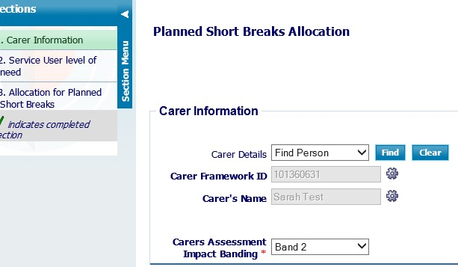

Section 2
Determine the level of need that best reflects the adult who is cared for being cared for. A set of descriptions has been agreed for people who would be classed as having low, medium, high or complex needs. This includes all aspects of care needed and support during the night as well as in the day. Staff must choose the most appropriate level that represents the adult who is cared for and enter the level into Mosaic.

Section 3
The system will allocate a particular level of indicative personal budget for planned short breaks to the service user. The value of this is based on a combination of: the level of “impact of caring” on the carer and the level of the adult who is cared for needs in line with the Planned Short Breaks Matrix (see below). The NHS Short Break expenditure will be subtracted from the overall allocation, determined by the Planned Short Breaks Matrix.

If an additional amount of funding is required in exceptional circumstances this can be added along with an explanation, in this section. This must be approved by your manager. (Please see Section 6 for further explanation of exceptional circumstances)

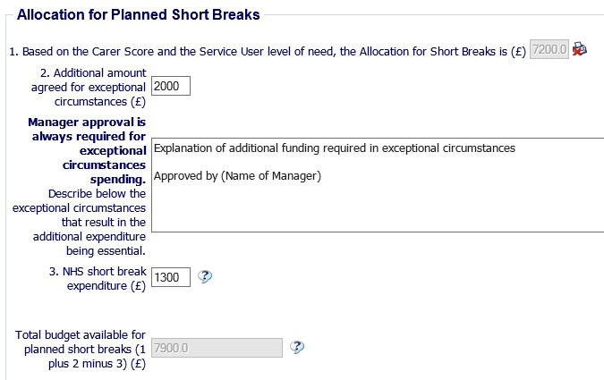

Planned Short Breaks Matrix

The Providing Planned Short Break Services for the adult who is cared for and their Carers guidance, explains that the total amount of personal budget to be awarded to fund planned short breaks is determined by combining the level of “impact of caring” on the carer and the level of the adult who is cared for needs. (See Section 15 for ‘the adult who is cared for Level of Need – definitions’) The result produces an indicative allocation of one of four bands of personal budget, to be commissioned as a lump sum in the service user’s name.

  - The carer’s banding determines the number of weeks funded
  - The level of the service user’s needs determines the amount of funding allocated per week.

1 weeks’ worth of residential planned short breaks for Band 1 Carers (7 nights) 2 weeks’ worth of residential planned short breaks for Band 2 Carers (14 nights) 4 weeks’ worth of residential planned short breaks for Band 3 Carers (28 nights) 6 weeks’ worth of residential planned short breaks for Band 4 Carers (42 nights)

Low level people – funded at £600 per week
Medium level people – funded at £800 per week
High level people – funded at £ 1200 per week
Complex level people – funded at £ 1500 per week

Cared for - Low |  |  | Cared for -Medium |  | Cared for -High | Cared for -Complex
Carer Band 1 |  | £600 |  | £800 | £1,200 | £1,500
Carer Band 2 | £1,200 |  | £1,600 |  | £2,400 | £3,000
Carer Band 3 | £2,400 |  | £3,200 |  | £4,800 | £6,000
Carer Band 4 | £3,600 |  | £4,800 |  | £7,200 | £9,000

Although these levels are expressed as nights, the funding can be used in more creative ways as well (see section 1.1).

Deciding the appropriate level of personal budget for planned short breaks

See process map 1 – short breaks allocation set up.

  - The most cost-effective form of planned short break must be offered. The person may not need the whole indicative budget to fund the appropriate level of planned short break, so staff must only commission what level of funding is needed and will be used throughout the year. There is no need for the family to “save up” the money in case of any emergency; the point of this budget is to use it to have a break and take a rest.
  - Remember – this is about extra service, on top of (or instead of) the normal routine of caring and service.
  - Staff must stay within the indicative level of personal budget that has been allocated for the short break. If this level is not sufficient to fund the type of service that is needed, staff should refer the case to Panel or their group manager, explaining what has been allocated, what level of funding is needed and reasons supporting this. If the request for additional funding is agreed, a case note should be entered onto Framework, stating the date when this was agreed and the reasons why.
  - Once the type and cost of planned short break that will be funded for the year has been agreed, workers need to enter this value into the support plan in the Planned
Short Break section and describe the type of service to be commissioned.
  - The Short Breaks Allocation Personal Budget for the next 12 months will then be “created” in Mosaic by the Service Placement Team.
  - The Short Breaks Allocation Personal Budget will not be used for commissioning until the actual planned short breaks are taken and need to be paid for.

Exceptional circumstances

Exceptional circumstances should be explored during the carer’s assessment or review and the service user’s care and support assessment or review, and discussed with the authorised budget holder to determine:

    - Any planned short breaks being allocated to any service user
    - The context of the family situation e.g. the intensity of the caring situation and the carer’s individual needs related to age, or any ill health or disabilities.

Booking the planned short break

Managed service

If the carer or the adult who is cared for contacts the Customer Service Centre when they want to book a break, the Customer Service Centre will:

Step one
Check to see if the carer has a NHS Carers Breaks allocation and then:
    - If the carer has not been assessed/ reviewed for a Carer’s NHS break, the advisor will
complete a Carer Contact in Mosaic and pass to the Carers Support Service within the Adult Access Service
    - If the carer has an allocation outstanding from the Carer’s NHS Break, the advisor will complete a CSC update message and pass to the Carers Support Service within the Adult Access Service for them to book a break.
    - If the carer has used their NHS allocation or there is insufficient funding to proceed with the break, the advisor will proceed to step two.

Step two
Check to see if the cared for adult has a Short Breaks Allocation in Mosaic and then:
    - If the cared for adult does not have an allocation, the advisor will send an update message to the appropriate team to bring forward a review
    - If the cared for adult does not exist on Mosaic the advisor will complete a Contact step in Mosaic and send to the appropriate team
    - If the cared for adult has a Short Breaks Allocation the advisor will proceed to step three.

Step three
    - Check the total remaining allocation in the Personal Budget
    - Complete the Planned Short Break update message in Mosaic and send through to the appropriate operational team or learning disability short breaks unit
    - If there is insufficient budget left to fund a requested short break, then the social care worker must inform the carer of this situation and direct him/her back to the case worker.

PLEASE NOTE: The details referred to in the process maps are in relation to Framework – these may have changed since the implementation of Mosaic. Please contact the Mosaic Development Team if you require assistance

See Process map 2 – checking level of available short break allocation See Process map 3 – request short break commissioning

Using a direct payment for a planned short break

If the service user decides to take the personal budget for planned short breaks as a direct payment, the lump sum will be paid out to him/her in 13 instalments; i.e. every 4 weeks throughout the year. If this does not suit the family because of when they need to pay for a planned short break, the case worker should send an email through to the ACFS DP inbox, to request how much is needed and when.
The preference is for cared for adults to use pre-payment cards to purchase their planned short breaks; staff should to raise awareness of pre-payment cards and support their usage. See the fact sheet on Direct Payments Pre-Paid Debit Cards

What to do if the combined cost of the service user’s personal budget and the personal budget for planned short breaks is very high

At the point when the cost of the cared for adult’s personal budget (including planned short breaks during the year) exceeds the expected cost of supporting that person in another form of service (e.g. residential care or supported living), then discussions should be held with the family to consider the options.

Charging for planned short break services

When the personal budget for short breaks is used to fund residential care, Shared Lives or community-based services, the service user will be charged according to the Care Act 2014
– Care and Support Statutory Guidance, chapter 8, charging and financial assessment, at the time when the short break is taken. See the Council’s Contributions towards a Personal Budget Guidance.

All staff need to remind carers that if they cancel their planned short break, they need to give as much notice as possible. This is to ensure that the Local Authority does not lose money unnecessarily.

Transition period
It is anticipated that most carers and cared for adults will be moved onto the new allocation immediately.

However, a transition period will be allowed for people who are allocated a SIGNIFICANTLY LOWER ALLOCATION OF NIGHTS THAN THEY CURRENTLY RECEIVE (this may particularly affect users of the Learning Disability Short Breaks units). In these exceptional circumstances, it has been agreed that a phased approach may be taken. There will be a period of 2-3 years for the allocation to be reduced for those carers who would find it difficult financially or emotionally to accept the reduced amount immediately.

PLEASE NOTE: The details referred to in the process maps on the following pages are in relation to Framework – these may have changed since the implementation of Mosaic. Please contact the Mosaic Development Team if you require assistance.

Process Map 1 – requesting a short break allocation

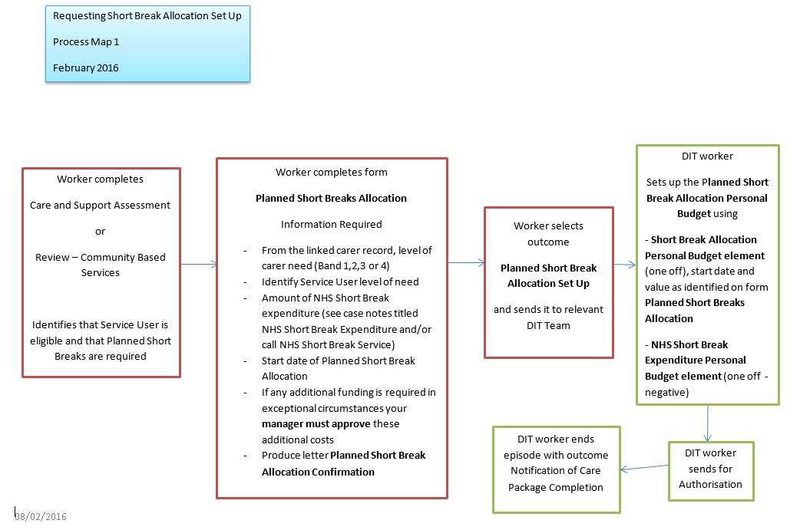
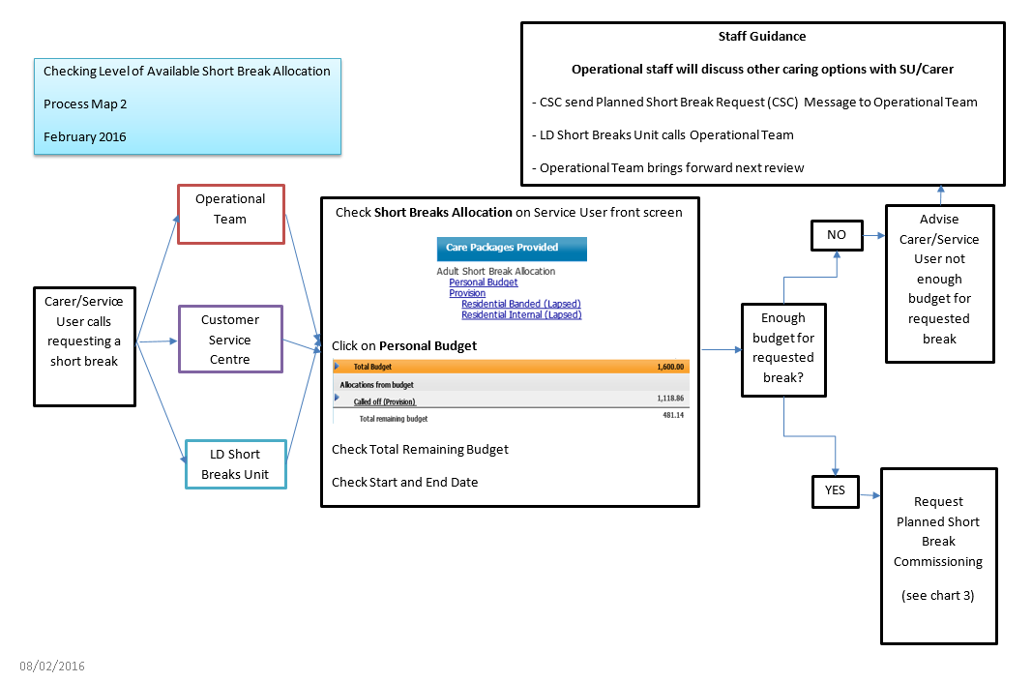
Process map 2 – checking level of available short break allocation

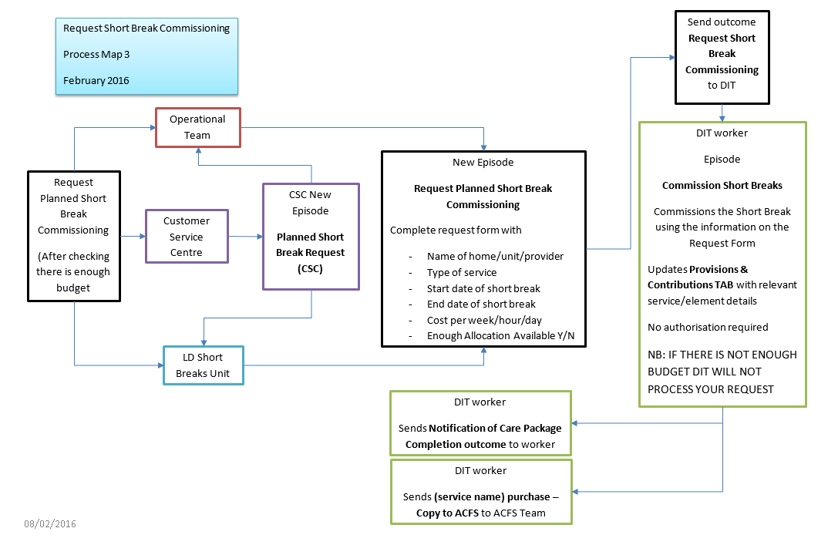
Process map 3 – request short break commissioning

- Adults who are cared for Level of Need – definitions

Low
1 People at this level do not have behavioural issues or cognitive impairment which affect the things they want to do. General oversight is needed with minimal intervention. People may need encouragement to do tasks or activities.
2 No regular support is needed during the night, although an “on-call” system may be in-place.
3 People at this level do not have physical or sensory or personal needs which affect the things they want to do, although they may need prompting to eat, drink and carry out personal care tasks.

Medium

- People at this level have behavioural issues or cognitive impairment which directly affect the things they want to do, on occasions during the day, but do not curtail or prevent them.

- People at this level have physical or sensory or personal needs which require changes or restrictions to the things they want to do on a regular basis.

- The person may require support from someone else during the night (e.g. for reassurance, to help them back to bed, to assist with physical care, to give medication).

- Continence care is routine and managed on a day-to-day basis, which could be with direct support from another person.

- Communication about needs is difficult to understand or interpret or the individual is sometimes unable to reliably communicate, even when assisted. Carers or care workers may be able to anticipate needs through non-verbal signs due to familiarity with the individual.

- The person has a level of cognitive impairment that could include frequent short-term memory issues and maybe disorientation to time and place. The individual has awareness of only a limited range of needs and basic risks. Although they may be able to make some choices appropriate to need on a limited range of issues, they are unable to consistently do so on most issues, even with supervision, prompting or assistance.

High

- People at this level have behavioural issues which can severely restrict the things they want to do, such that they need close oversight for prolonged periods.

- Continence care is routine but requires monitoring to minimise risks, for example those associated with urinary catheters, double incontinence, chronic urinary tract infections and/or the management of constipation.

- The person needs one person to be directly involved with personal care tasks.

- Mood disturbance, hallucinations or anxiety symptoms, or periods of distress, happen on a regular basis and have a severe impact on the individual’s health and/or well- being.

- The person will require support from one person during the night, more than once each night (e.g. for reassurance, to help them back to bed, to assist with physical care, to give medication).

- The person has a cognitive impairment that may, for example, include, marked short- term memory issues, problems with long-term memory or severe disorientation to time, place or person.

- Physical condition :
  - The person is completely unable to weight bear and is unable to assist or cooperate with transfers and/or repositioning, or
  - Due to risk of physical harm or loss of muscle tone or pain on movement, the person needs careful positioning and is unable to cooperate, or
  - The person has a high risk of falls (as evidenced in a falls history and risk assessment), or
  - Involuntary spasms or contractures placing the individual or others at risk.

- The person has dysphagia which requires skilled intervention to ensure adequate nutrition / hydration and minimise the risk of choking and aspiration to maintain airway.

- The person requires administration and monitoring of medication regime by a registered nurse, carer or care worker specifically trained for this task because there are risks associated with the potential fluctuation of the medical condition or mental state, or risks regarding the effectiveness of the medication or the potential nature or severity of side-effects. Even with such monitoring the condition is usually problematic to manage.

Complex

- The person has Continuing Care Funding from Health (100%), or

- Must meet 2 of the following conditions :
  - Risk assessment identifies that the person’s behaviour(s) require(s) a prompt and skilled response that might be outside the range of planned interventions. The risks are so serious that they require access to an immediate and skilled response at all times for safe care.

  - Cognitive impairment: The individual is unable to assess basic risks even with supervision, prompting or assistance, and is dependent on others to anticipate their basic needs and to protect them from harm, neglect or health deterioration.

  - The person will require support from two people during the night, more than once each night (e.g. to help them back to bed, to assist with physical care, to give medication, pressure care).

  - Complex health needs – i.e.
    - Continence care is problematic and requires timely and skilled intervention, beyond routine care (for example frequent bladder wash outs, manual evacuations, frequent re-catheterisation), or

    - The person is completely immobile and/or in such poor clinical condition that, in either case, on movement or transfer there is a high risk of serious physical harm and where the positioning is critical, or

    - The person is unable to take food and drink by mouth. All nutritional requirements taken by artificial means requiring ongoing skilled professional intervention or monitoring over a 24 hour period to ensure nutrition/hydration, for example I.V. fluids, or

    - The person has a drug regime that requires daily monitoring by a registered nurse to ensure effective symptom and pain management associated with a rapidly changing and/or deteriorating condition.

    - The person is unable to reliably communicate their needs at any time and in any way, even when all practicable steps to assist them have been taken. The person has to have most of their needs anticipated because of their inability to communicate them.

Appendix 1

NHS Funded Carers’ Breaks Service: NCC Staff Guidance, October 2017
This document provides staff at Nottinghamshire County Council with guidance on Personal health budgets for the NHS funded carers’ breaks service. Personal Health Budgets for NHS funded carers’ breaks are available via a direct payment or managed by Rushcliffe Clinical Commissioning Group (CCG) on behalf of the 5 CCGs in South and Mid-Nottinghamshire.

1. Background
Management of the NHS Funded Carers Breaks service transferred from Arden and GEM CSU to Rushcliffe CCG on 1 July 2015.

Within the first 12 months of the transfer, Rushcliffe CCG undertook a review of the service to more clearly define its remit.

This guidance outlines the current provision which now forms part of the integrated personal commissioning delivery programme.

2. The Service
The CCGs provide a joint source of funding to support carers in taking a short break from their caring role if this has been identified as an outcome in their care and support plan.

A carer’s personal health budget can be taken in three ways:
- A managed budget
- A direct payment
- A mixture of both
The total cost of the care must be within the budget allocation.

The process for a managed service is for Nottinghamshire County Council (NCC) to send a referral via email to Rushcliffe CCG on ruccg.carersbreaksservice@nhs.net. The referral is be checked against eligibility criteria and, if met, approval is secured from the relevant Lead Nurse of the responsible CCG. Providers i.e. care homes and home care agencies are then advised of invoicing arrangements and these are processed by Rushcliffe CCG.

The carer may also access funding via NCC for a direct payment to commission care from providers of the carer’s choice where there is no contract in place. This option offers the carer more choice, control and flexibility over how to use the personal health budget to take a break. The carer can find solutions that may not have been available in the past e.g. to organise a personal assistant to provide care at home or pay for a carer to join them on holiday to provide a break whilst away from home(this funding source is managed by NCC and also available to carers in Bassetlaw).

A carer can choose to take a mixture of both a managed payment and a direct payment so long as the cost of care is within the budget allocation.

3. Personal Health Budget Allocations for Carers Breaks
The amount of funding available for a carer as a personal health budget (PHB) is dependent on the level of need as determined by the NCC carer’s assessment.

Carers assessed as having:

- ‘High impact’ needs can access a PHB of up to £650.
- ‘Extremely high impact’ needs can access a PHB of up to £1300.

The rationale for these indicative budget allocations are that they relate to the charge for 1 and 2 weeks respite in a NCC Care and Support centre.

The budgets are for use within a 12-month period from the date of the assessment/review. It is anticipated that most carers will not require all of the indicative budget. The amount required will depend on the carers needs for a break as set out in their support plan.

4. Eligibility Criteria

To be eligible for a ‘managed service’ AND/OR a Direct Payment:
- The carer and cared for must BOTH be registered with any of the following CCG’s - Rushcliffe, Nottingham North & East, Nottingham West, Newark and Sherwood and Mansfield and Ashfield
- The carer and cared for must BOTH be resident in Nottinghamshire County (except City and Bassetlaw*)
- The carer and cared for must be aged 18 or over
- The carer must have had a NCC Carer’s Assessment undertaken within the last 12 months of the date of the break
- The carers needs must be defined by the Carer’s Assessment as having either a high impact (showing an indicative carer’s personal budget as £150) or an extremely high impact (showing an indicative carer’s personal budget as £200).

*Bassetlaw is via Direct Payment ONLY and:

- The carer and/or the cared for must be registered with Bassetlaw CCG. If either the carer or cared for are not registered with Bassetlaw CCG, they must be registered with one of the other Notts CCG’s as listed above (excluding Nottingham City)
- The carer and cared for must both be resident in Nottinghamshire County (except City)

5. Defining an NHS Funded Carer’s Break

These definitions are applicable to both PHBs managed by Rushcliffe CCG and also via direct payments.

A carer’s break is:
- A pre-planned break from caring;
- Of primary benefit to the carer e.g. to support them in taking a break from their caring responsibilities such as to take a holiday;
- Likely to be a one-off stay for the cared for in a care home, care agency or personal assistant support in the cared for’s own home or day care;
- ‘Short’ e.g. a week or two.

A carer’s break isn’t:
- For support in an emergency situation or for crisis prevention (consider use of the Carers Crisis Prevention Service);
- For intermittent/fragmented support over a period of weeks/months providing regular ongoing care for the cared for;
- Part of a longer term placement in a care home e.g. for short-term care to trial a placement before a permanent move;
- About accessing the entire potential allocation i.e. the funding allocation is a limit not a ‘target’.
6. Referral Information
If the carer has chosen a care provider which has a contract (formerly described as an ‘AQP’), Rushcliffe

CCG will manage the carer’s PHB and pay for the care direct. Referrals should be directed to ruccg.carersbreaksservice@nhs.net and must fulfil the following requirements:
- The request should be received >5 full working days before the start of the break.
- All referral information should be correctly completed using the form on Mosaic and a case note added;
- It should be sent securely (i.e. via an email address ending in .x.gsi.gov.uk; .gsi.gov.uk; .gse.gov.uk; .gsx.gov.uk; etc. or via Cryptshare);
- No retrospective requests will be accepted.

Referrers are required to inform the service if the break doesn’t take place or if there are changes to the break as originally requested.

- Services for the Cared For

7.1 Planned Short Breaks

If the ‘cared for’ is eligible for NCC services, planned short breaks can also be commissioned in their name through the NCC. The NCC’s Short Breaks Policy provides a matrix to illustrate an indicative personal budget.

The matrix combines the needs of the carer with those of the cared for to indicate a maximum allocation.

If planned short breaks are already being accessed through NCC, it is proposed that an NHS funded carers break would only be supported if the indicative budget would not be exceeded when taking into account the funding available through the NHS.

7.2 Continuing Care

If the cared for is eligible for either continuing NHS healthcare or a jointly funded package, then any breaks required for the carer would be commissioned as part of the continuing care package and funded according to the assessed health and social care needs of the cared for.

- Cost of Care

8.1 Care Home Placements

NCC and Nottingham City Council have agreed standard rates for placements with most of the homes in Nottinghamshire. Every effort should be made to adhere to the Local Authorities’ standard rates for NHS funded carers’ breaks.

If a home has been identified out of area, similarly, every effort should be made to adhere to that area’s Local Authority standard rates.

8.2 Home Care
The CCGs are associate commissioners to NCC’s home care contract. Services commissioned from contracted home care providers have associated rates which are also applicable to carers’ breaks.

The CCGs may also negotiate rates with non-contracted home care providers i.e. through the continuing care service and these too are applicable to carers’ breaks.

9. Direct Payments
A carer can choose a Direct Payment via NCC to commission care from providers of their choice. This gives the carer more choice, control and flexibility over how they can use their personal budget to take a break.

For the carer to access a Direct Payment, the same eligibility criteria applies as per the managed service.

The same principles also apply for carers as for any other service user who wish to receive their personal budget as a Direct Payment. The Direct Payment is paid directly to the carer (not the ‘cared for’).

A carer can also have the option of a Managed Budget and Direct Payment combined, as per any other service user. If a carer chooses to do this, the budget can be monitored in Mosaic, via ‘Provisions’ within ‘Personal Budgets’ section on the front screen of the carer’s record.

Please see the attached link here for Direct Payments staff guidance for further information: Direct Payments for Adults - Staff Guidance

For carers that are registered with a Bassetlaw GP, NHS Short Breaks are only available to carers via a Direct Payment (see point 4. Eligibility Criteria above for more details).

